FAST® Releases 2017 Ignition Catalog

Memphis, TN – FAST® has released a new catalog tailored toward ignition control and components.

With the long-standing EFI and emerging ignition leader's recent brand expansion to include a full line of high performance ignition components, the Ignition division developed a new catalog featuring 32 pages of full-color photos and detailed product information. It covers ignition systems, distributors, crank triggers, coils, points conversion, spark plug wires and much more. It is a must-have for enthusiasts and racers demanding cutting-edge technology.

The new FAST® Ignition Catalog is available for download at cpgnation.com and can also be found at shows, races and other events throughout the year.

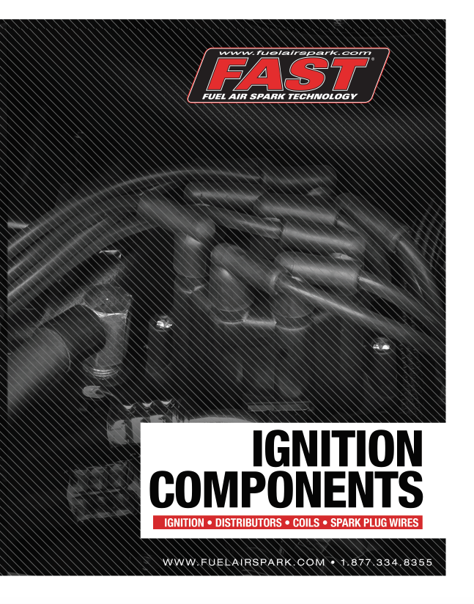
Quick Facts

Products: FAST® 2017 Ignition Catalog
Part Numbers: #F2017-1

Social Media Pitch: FAST® has recently introduced a new 2017 Ignition Catalog

Features & Benefits:
32-Page Ignition Catalog provides detail on ignition systems, distributors, crank triggers & related components + FAQs & tech info
New full-color catalog is available at cpgnation.com, as well as shows, races & other events

About FAST®

In 2001, FAST® was acquired by the COMP Performance Group™ and moved its headquarters to Memphis, TN, to become the popular electronics company that we know today. After more than a decade in the performance aftermarket industry, FAST® is the recognized leader in advanced EFI technology. Now, not only does FAST® offer the components to adapt virtually any engine to fuel injection, it is also an emerging force in the ignition market. With the latest in easy-to-use electrical components, the experts at FAST® have everything that you need to make high-tech horsepower. Additional information about FAST® and its products can be found at www.fuelairspark.com or at 1.877.334.8355. Also visit us on Facebook at facebook.com/FASTWins, on Twitter at twitter.com/FASTEFI or on YouTube at CPGNationTV.com.

Media Contact: Cindy Bullion, cbullion@compcams.com, 901.795.2400 ext. 1643.

